**App Documentation: Cinema App**

The objective of the creation of this app is to apply the knowledge of the topics described in this training, guiding with the steps of implementation and good practices. Below it is described the features of the app as well of the design of it.

Overview

The app displays the movies currently in the local cinema from a public API Movies repository showing highlight information of each movie. The app should save in offline mode the favorites selected movies.

Requirements

The Cinema app accomplish some basic requirements that are presented in the next user case diagram and described below.

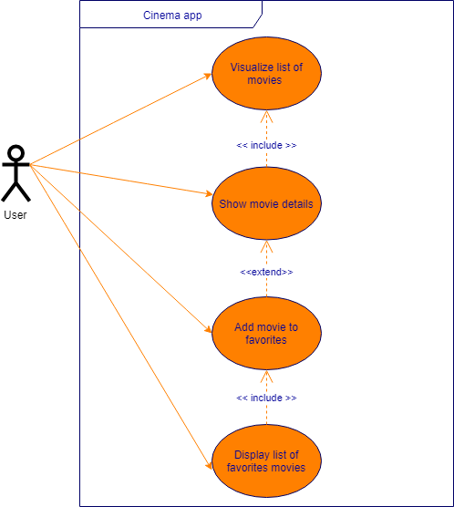

The app requires to use the design architecture: MVP

Page Break

**User stories**

*US – 1:* Movie’s list

 As a user, I want to visualize the list of movies so I can view a list of new releases movies.

Acceptance criteria:

* The movies should be presented in a list
* Each movie it should show a preview of its poster and a short paragraph of its overview
* It should display at least three movie items in the normal screen view
* The list of movies should be showed as default when the app starts.
* The information of movies should be retrieved by API Movie database.

*US – 2:* Movie details

As a user, I want to show the movie details so I can know more about the movie.

Acceptance criteria:

* The information that should be displayed in this screen are:
* Title
* Poster image
* Release date
* Overview
* Review average

*US – 3*: Favorite movie

As a user, I want to add the movie to favorites so I can save my preferred movies to watch it later.

Acceptance criteria:

* The screen of movie details should have an icon to favorites and the upper right.
* The favorite state should persist.

*US – 4*: Favorite list

 As a user, I want to display a list of favorite’s movies so I can watch my preferred movies previously selected.

Acceptance criteria:

* It should show a list of the favorite movies previously selected
* The list showed should be showed even without internet connection.

*Definition of DONE*

* Create branch per user stories.
* There should be a branch of development and a productive (it will the master branch).
* It is required a week version release.
* There should be at least a 65% of code testing coverage.

References: <https://www.yodiz.com/blog/writing-user-stories-examples-and-templates-in-agile-methodologies/>Page Break

Mockups

C:\Users\muj1ga\AppData\Local\Microsoft\Windows\INetCache\Content.MSO\C7F40415.tmp

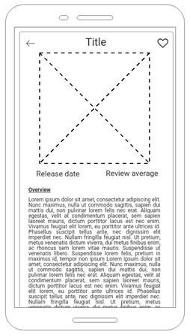

Icons

Empty favorite:   C:\Users\muj1ga\AppData\Local\Microsoft\Windows\INetCache\Content.MSO\9DA2B267.tmp

Selected favorite:C:\Users\muj1ga\AppData\Local\Microsoft\Windows\INetCache\Content.MSO\D026300D.tmp

Access link to mockups: <https://wireframepro.mockflow.com/view/Me89b0d26a952b2d56a8f533cecc6024a1568828244669>

Useful links for UI:

<https://design4users.com/ui-for-movies-collection-of-cinema-app-designs/>

<https://medium.muz.li/ui-ux-case-study-designing-a-better-cinema-experience-29abc7cfb94f>Page Break

The Movie Database API: Structure and use

The next API has a free movie repository where it can retrieve general information about movies in theaters. It requires creating an account; a due to the training context of this application, the developer account is required. In order to make test, the API give a test site to probe the different web calls: <https://developers.themoviedb.org/3/getting-started/introduction>

API Key

The base URL to retrieve movies information is with <https://api.themoviedb.org/3/> . This URL needs an API Key that can be accessed after create an account and select API option in the [settings](https://www.themoviedb.org/settings/api) of the account. This field should be sent in every call as a *query_param.*

Get current movies listing

The web call necessary to get the list of movies that is playing in theaters currently is the next one <https://api.themoviedb.org/3/movie/now_playing> with the parameters of *page* and *region*. In the case of region is necessary to set it as *MX* while *page* field works as division of results due to every page display only 20 results, in the case of a 35 results, the web call is divided in 20 results in the first page and 15 in the second one.

The response follows the next structure:

* (root):5 Items
* **results**: 20 Items
* page:1
* **total_results**:35
* dates:2 Items
* **total_pages**:2

There will be as many request as the *total_pages* in the response. The *total_results* field will work to set a limit in the number of items of the movie list. The most important fields to use in the in an item within the results array are *title, poster_path, vote_average, release_date* and *overview.*

Retrieve images

It is necessary to build a three parts URL image file obtained of two web-calls. The first one is the previous call of movie listing, which has the field of *poster_path*. The next call is */configuration* which retrieves the field *base_path* and *file_size*. After get, these three paths the structure of the path is as follows:

*base_path / file_size /poster_path*

Links for API: <https://www.themoviedb.org/documentation/api>

**Screens:**

**Pre-Login:**

**Página con descripción y botón login en parte superior derecha**

**Home:**

Agregar menú con opciones de home, favoritos, y agregar buscador, modo oscuro, mostrar nombre del usuario en caso que el token lo proporcione.  
Lista de Películas con Nombre, Imagen, Resumen, agregar icono para favoritos

**Favoritos**

Agregar menú con opciones de home, favoritos, y agregar buscador, modo oscuro, mostrar nombre del usuario en caso que el token lo proporcione.

Lista de Películas con Nombre, Imagen, Resumen, agregar icono para favoritos

Buscador aplicaría la búsqueda dependiendo en donde se encuentra el usuario (home o favoritos)

**Detalle de la Película:**  
Nombre Resumen, Imagen, Video, Rating, Agregar a Favoritos, Género, películas sugeridas

**Tecnologías:**

* Expo
* React navigation
* React Native Elements
* Axios
* Redux

Rest request Axios:

https://github.com/axios/axios

Register:

https://www.themoviedb.org/signup